**Applying for research funding**

***1. Read the following extract from a scholarship offer program and then answer the questions***:

1. Can an organization apply for the scholarship?
2. Would you be interested in applying for ESRC? Why? Why not?
3. What information might you need to include in your application form?
4. Is there a particular area of research that is given priority?
5. What do you think about the mission of the ESRC Society?
6. How is providing money to (novice) researchers at the beginning of their careers seen as an “investment”?

|  |
| --- |
| **About the project** |
| The ESRC Research Grant Civil Society aims to develop STEM Education in Wales by attracting outstanding professionals in the field of Computer Science to continue their academic track in a British university. The fellowship is funded by the University of South Wales as part of the university’s contribution to the new ESRC Research Grant Civil Society – Civic Stratification and Civil Repair awarded to the Wales Institute of Social and Economic Research, Data and Methods (WISERD) Research Centre.  ESRC fellowships are awarded to individual students worldwide with future potential for leadership in their field. Applicants should have a very good BSc (Honours) (First or Upper Second class) degree or a Master degree (with Distinction or Merit) in Computer Science or related disciplines. Successful applicants receive a 4-year grant covering salary, travel and relocation costs. |

**2. Extension activity: investigating a fellowship**

*2.1 Think about several additional questions that would help you obtain more information about the fellowship in Exercise 1a.*

* Suggested questions:

1. Can candidates apply over consecutive years?
2. Will the fellowship committee help in obtaining a visa?

*2.2 Write an email to the fellowship committee asking your questions.*

* Also consider the following example, for more practice: <https://www.findaphd.com/phds/project/real-time-iot-analytics-at-edge/?p128999>
* To discuss more options regarding PhD offers, also see: <https://www.findaphd.com/phds/maths-and-computing/?10gw00&PG=2>

*2. Eriko has decided to apply to ESRC and has downloaded an application form. Look at the list of sections on the form (1-10) and match each one to Eriko’s notes on the information she needs to provide (a-j).*

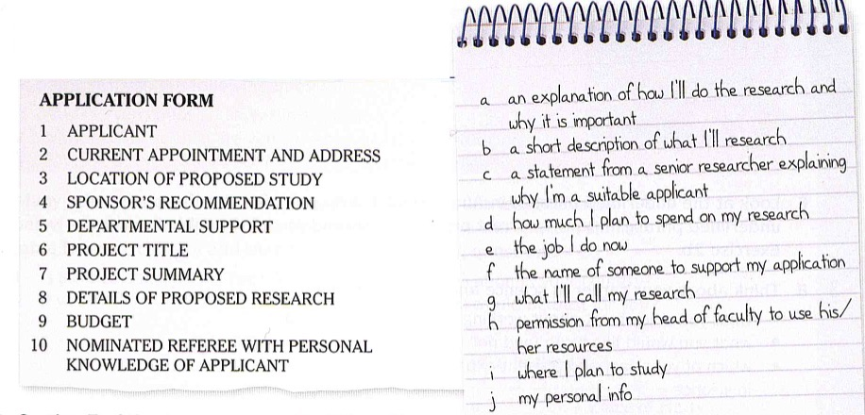

*3. Section 7 of the of the form asks applicants to write a project summary of their research proposal. Think about a research area (eg Human Computer Interaction/Networks, Distributed Systems and Security etc.) and a research topic (eg. “Efficient page preloading for SGX enclaves”) that you consider worth pursuing. Discuss the following aspects in your description:*

- Research area/Research topic

- State of the art in research (current research in an area/given topic)

- Why the topic is important

- What limitations do you see to your research

Language note

|  |
| --- |
| It is not uncommon for project summaries to be written in the 1st person plural (we), especially when the applicant is representing an institution/working with a co-author. |

*4. Below you will read a completed project summary on” Next-Generation Transport Protocols for Ultra-High Speed Networks”***.**

*Match the highlighted section in the summary (A-F) to the correct function (1-6) from the list.*

|  |
| --- |
| 1. State the aims of your research; 2. Define what the problem is/Identify the area for new work; 3. Explain why your topic/project is worth researching/endorsing; 4. Say what the expected outcomes (concrete goals and deliverables) of the research are; 5. Outline the procedure/methodology you will follow; 6. Outline how you will limit your investigation/the limitations of your project; |

**Next-Generation Transport Protocols for Ultra-High Speed Networks**

End-to-end data transfer rate requirements in the physics and astronomy scientific computation communities are soon to approach the terabit-per-second regime. Even for regular Internet, end-to-end transfer rate requirements of emerging digital media applications are likely to rise to at least the multi-gigabit regime. (A) However, data provided to date indicates that even when sufficient raw transmission capacity is available at individual links and routers traversed on an Internet path, such capacity cannot be made available to applications if the underlying transport protocols do not scale correspondingly. (B) Due to the prospective nature of the study and the highly restrictive paradigm of traditional research, the design framework of RTT-scale protocol operations was not included in our investigation. (C) We argue that a new approach could help design a novel paradigm of packet-scale congestion-control, in which the protocol operates at a frequency close to the frequency of packet transmissions. (D) This technology aims to develop the congestion-control timescale to be shrunk by several orders of magnitude over current protocols, especially in high-speed networks. (E) The innovativeness and nature of this project requires a research methodology that adopts both theoretical analysis and formal modelling, as well as practical system design, implementation, and experimentation on wide-area high-speed networks. (F) This project should produce a significant performance leap—while the best of current protocols are struggling to achieve 10Gbps transfer speeds, the paradigm enables comfortable operation at terabit- and-higher speeds. This is the first end-to-end congestion-control protocol for TCP/IP networks to achieve this scale.

5. *Complete the project summary by another researcher below using ONLY the correct word or phrase from the box.*

|  |
| --- |
| **the proposed research, although, the state of the art, to demonstrate, this project explores, tested and applied, however, to achieve this, addressed, existing methods, this model, aims to, this work, to mitigate** |

Fluid phenomena play important roles in everyday life - jet streams, chemical dispersion, granular flows, et cetera. 1)___________ these phenomena are commonplace, mathematical models that describe them properly are nonlinear and lead to computational simulation processes that are very complex and challenging to perform efficiently. 2)______________ the phenomena of high-energy fluid elastic solid interaction. 3)________________ for this type of interaction are better suited for lower energy scales. 4)___________ this work 5)___________ capture shocks and other phenomena requiring compressible flows in a high-energy state. 6)______________, we employ a method known as *Residual Distribution Scheme* (RDS) for the fluid simulation [Roe 1987]. Our method has been 7)___________ to a number of challenging problems with applications in computer animation: (a) foggy air current speeding past an iconic bridge, rocking it back and forth, (b) a flow of solar particles passing over a space station suspended high above the Earth, (c) wind buffeting a skyscraper, causing it to bend and twist. 8)______________ the scalability of RDS, we have implemented our algorithm with the paralellization facilities provided by OpenMP. 9)__________ of parallel computing is well-suited to the multi-core, shared-memory architectures commonly available on desktop workstations and laptops. 10)_________________ is expected to be also directly applicable to many-core architectures.



Purpose of research summaries

*Read the following statements and decide whether they are true or false:*

1. A project summary lets readers get the gist or essence of your paper or article quickly, in order to decide whether to read the full paper.

2. Search engines and bibliographic databases use project summaries, as well as the title, to identify key terms for indexing your published paper.

3. You are usually expected to cite references in your project summary and give a brief description of the specific literature that informs your research.

4. The project summary should begin with a brief but precise statement of the problem or issue, followed by a description of the research method and design, the major findings, and the conclusions reached.

5. Exactly like a lay summary, or impact statement, project summaries aim at producing a short paragraph outlining the project content, aimed at non-specialists in the field and written in a way that they can easily understand.

6. Use the present simple tense to state what the project investigates, what its goals are, and to report general facts, then use the present perfect tense to discuss past research that is relevant to the current study.